Extend the intuitionistic logic Nature Deduction with

Kolmogorov double negation

# Idea

The difference between intuitionistic logic and classical logic is whether one has the excluded middle rule.

For the nature deduction we have the above rules for introduction and elimination.

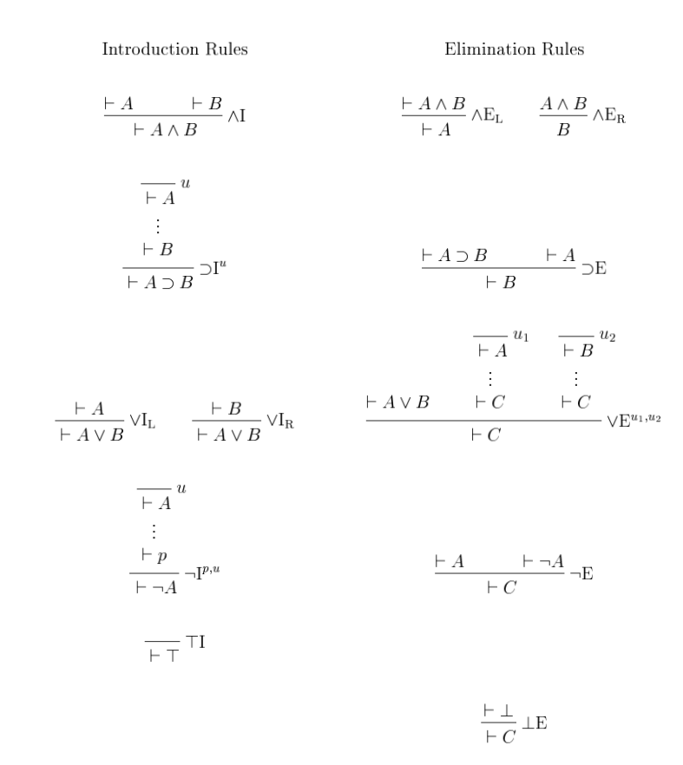

Nature deduction is intuitionistic logic since it doesn't force one complement for each proposition. If we use a ¬I on some proposition A and get ¬A. We can not repeat this process to ¬A and get back to A. This property makes ND non classical logic.

To extend ND to classical logic we need to make a rule to embed the excluded middle property. Our method is by adding the Kolmogorov double negation rule. The Kolmogorov double negation rule is that for some proposition ¬¬A, we can proof A. we call this rule ¬kdE(not Kolmogorov double Elimination, nkdE). With this new rule our new logic – ND with the Kolmogorov double negation rule, we call it KND is almost well defined. We need also to add the sole complement for ⊤, which is **⊥** as an atomic formula and it is now surely a classical logic.

Now in our hand we have the intuitionistic logic ND and classical logic KND. We want to show that both these two logic are “the same” by proving that for any logical formula provable in KND it can also be proven in ND(soundness) and any logical formula provable in ND can also be proven in KND(completeness).

To do this first we need to define a translation function that translates formulas in ND or KND to their counterparts. We use the ktrans–kolmogorov translation and it is defined as (n for ¬¬)

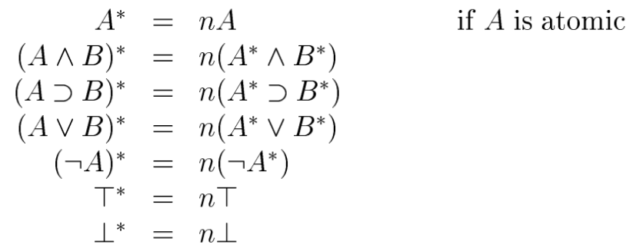

# Inference rule

Before we step into the proof of soundness and completeness we need some inference rule to help us eliminate double negation in ND.

First, since we can prove ¬¬A from A in ND we have the inference rule ¬¬X. Same with ¬¬kX

Also we can eliminate ¬¬¬A to ¬A, we make it as ¬¬¬R.

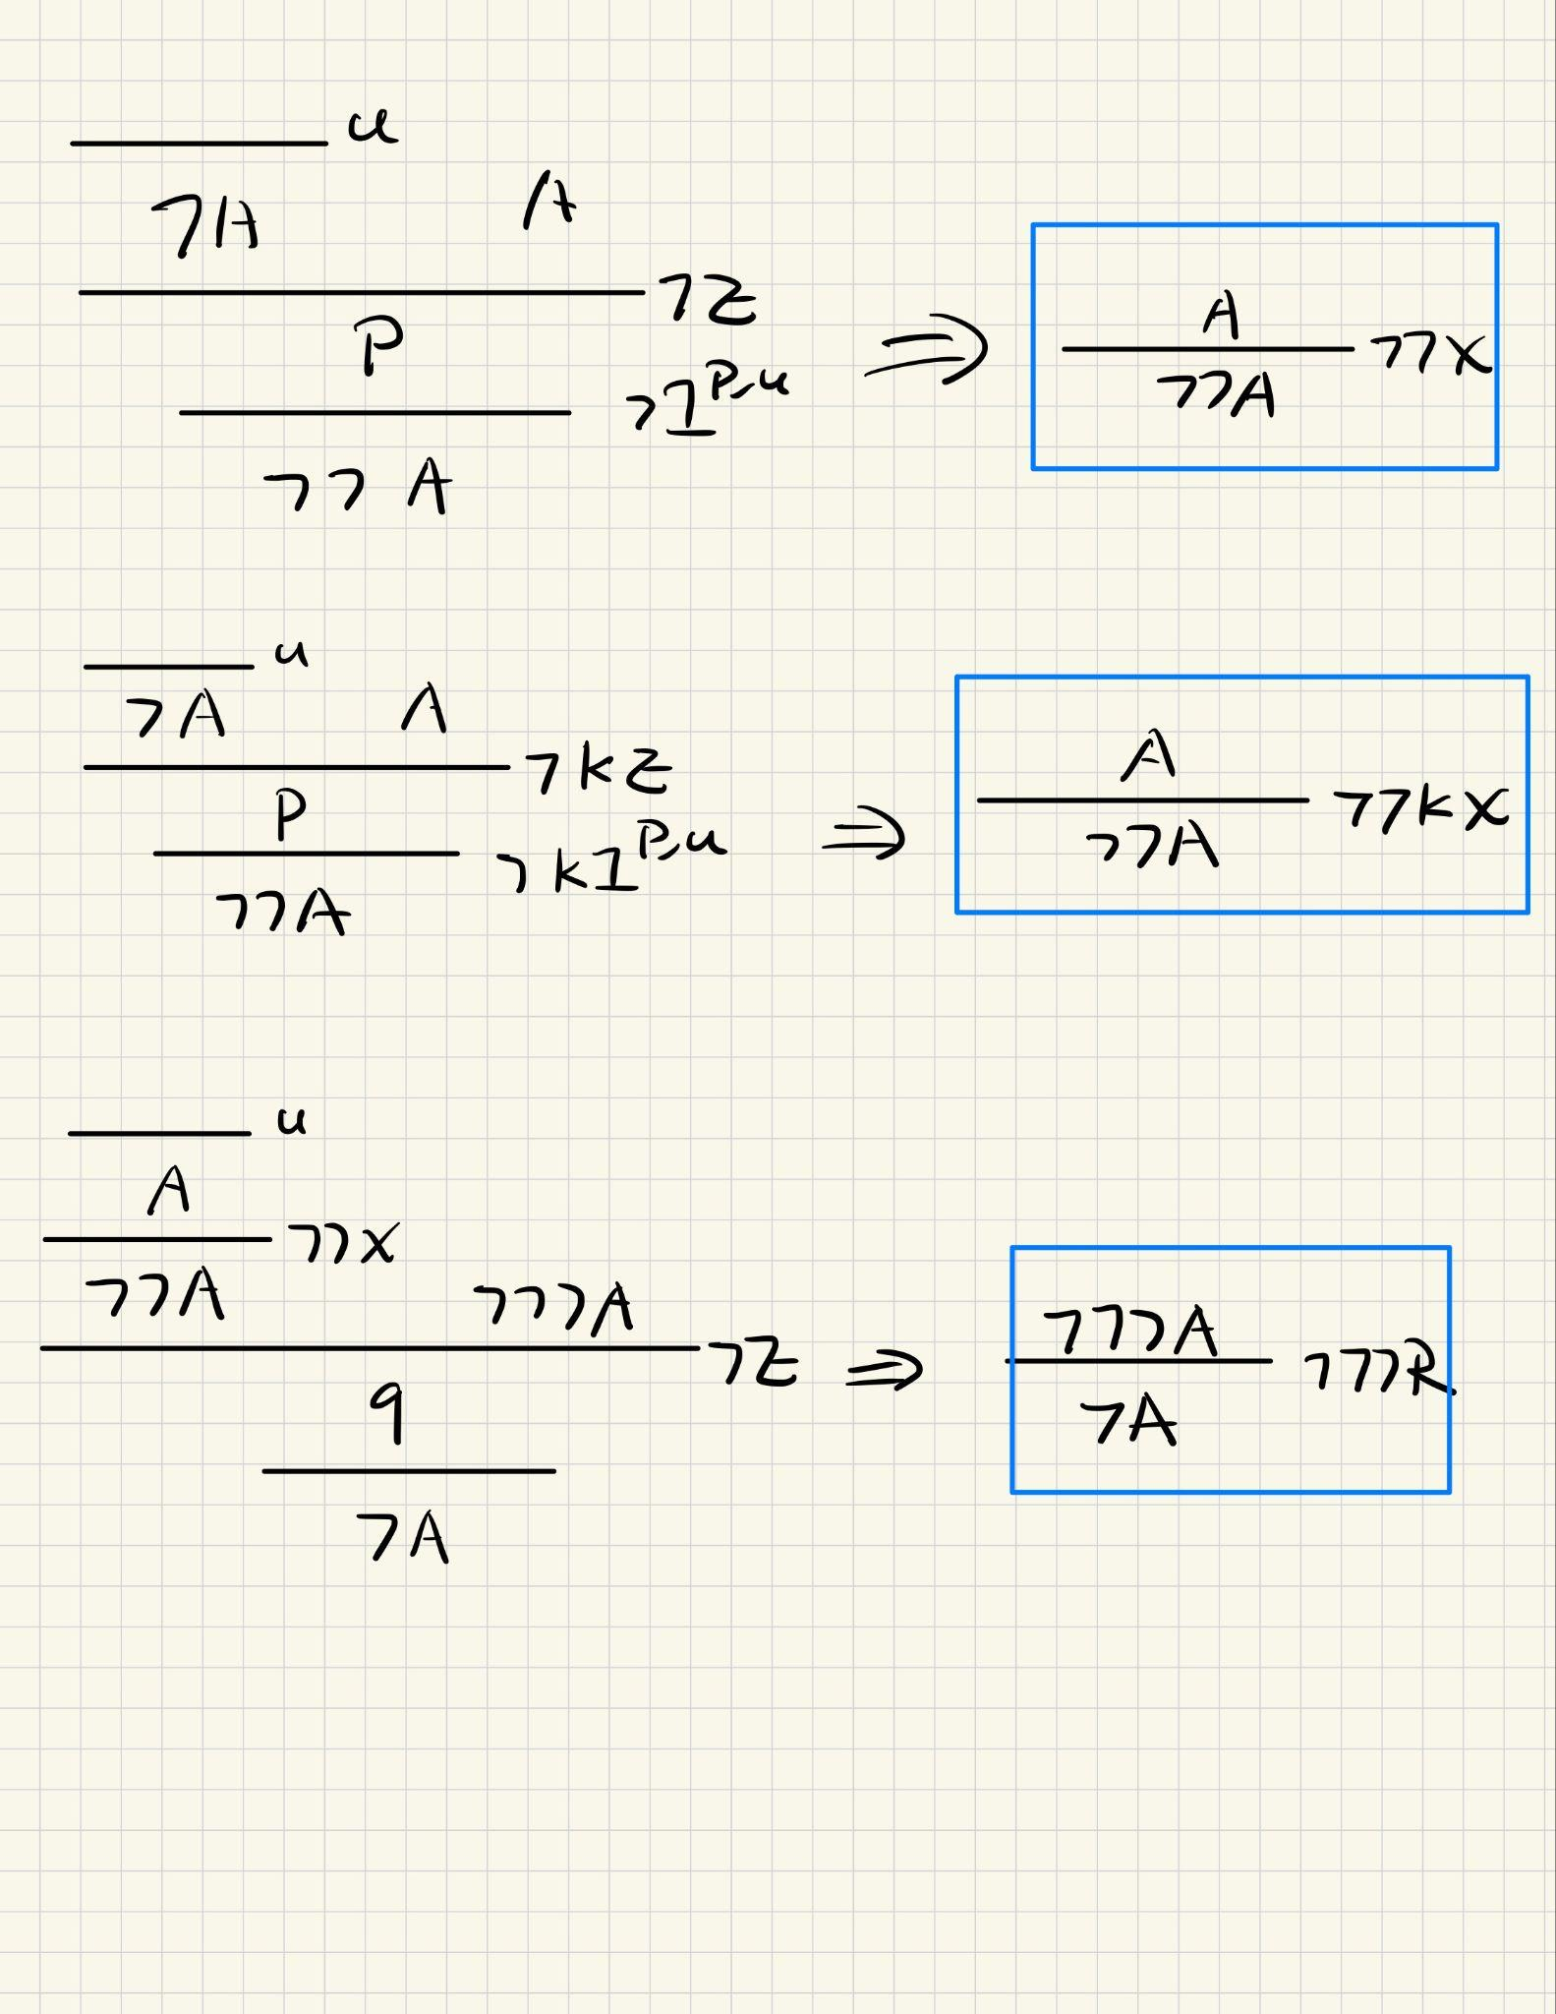

# Decomposability

//TODO

We need to show that for every formula A there exist a C such that A = ¬C

# Soundness

Now with the help of our derivation rule. We can prove our soundness theorm. We do structure proof on the last used operation.

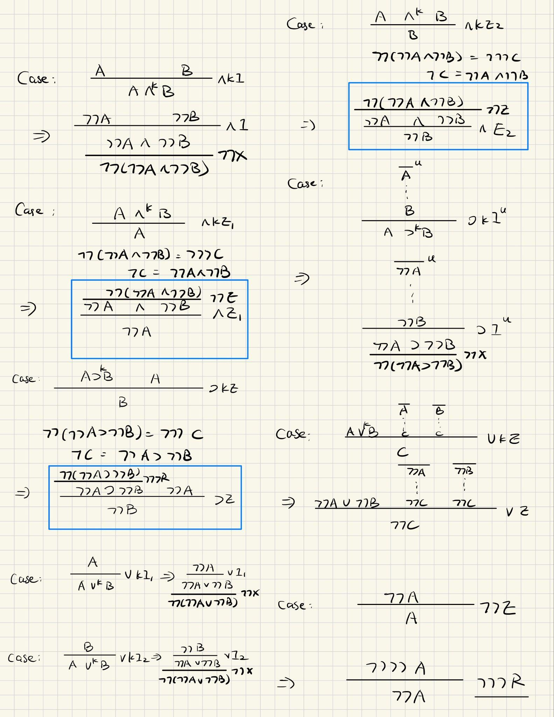

# Completeness

